# Daniel SUMMIT, Sr.

## Abstract

When Daniel SUMMIT, Sr. was born on April 5, 1795, in Lincoln, North Carolina, his father, Francis, was 54 and his mother, Dolly, was 40. He married Sarah MOSER on December 13, 1813, in his hometown. They had 12 children in 18 years. He died on September 30, 1838, in Monroe, Tennessee, at the age of 43, and was buried there.

*Birth: 5 Apr 1795 &bull; Lincoln County, North Carolina, United States, See Biography in Stories. See Comments: Moser-Blackman Transcriptions say 1795 (They carved the headstone in the early 1860s-ordered far after his death); Old St. Paul Transcriptions say 1797.; Marriage: 3 Dec 1813; Lincoln County, North Carolina, USA; Marriage: 13 December 1813; Lincoln County, North Carolina, USA, Probably in the St. John's Lutheran Church by Rev. Philip Henkel.; Residence: 1814; Second Reg. Mr, Lincoln County, NC; Residence: 1830; Jefferson, Tennessee, United States; Residence: 1830; Jefferson, Tennessee, United States; Death: 30 Sep 1838; Monroe County, Tennessee, United States, Age at Death: 43; Burial: Eve Mills, Monroe County, Tennessee, USA*

Daniel SUMMIT, Sr. was born on April 5, 1795, in Lincoln County, North Carolina, to Dolly DOE, age 40, and Francis SUMMIT, age 54[1]. He was the youngest son of Francis Summit, also known as Johann Frantz Sammet, a German Lutheran immigrant to North Carolina west of the Catawba River (Lincoln County) born in February 1741, probably in Germany. Francis probably arrived in North Carolina around 1768 and died in Lincoln County on February 27, 1818. Francis and Daniel signed the marriage bond with an "X" mark. Whoever wrote the information on the bond spelled it "Sommit." Sarah was a year younger than eighteen-year-old Daniel, having been born in Lincoln County on May 24, 1796, the daughter of Francis Moser, Sr**.**[2].

In 1795, North Carolina, in the southeastern region of the United States, had a population that included people from various ethnicities, genders, cultures, classes, religions, abilities, and identities. The population was approximately 500,000, mostly European settlers, including English, Scottish, Irish, and German immigrants. The Summits were German. There were also African Americans, both free and enslaved, who played a significant role in the state's economy and culture. Native American tribes, such as the Cherokee, also inhabited the region.

Agriculture was the backbone of North Carolina's economy. The state was known for tobacco, a major cash crop. Other important crops included corn, wheat, indigo, and rice. Many farmers relied on enslaved labor to work their plantations. Skilled artisans and craftsmen contributed to the economy through trades such as blacksmithing, carpentry, and pottery.

Religious diversity was present, at least the Christian variety, with various Christian denominations, including Anglicans, Baptists, and Methodists. Education was limited, but efforts were being made to establish schools and colleges[3].

Other events occurring in 1795 included the 11th Amendment to the US Constitution being ratified which affirmed the power of the states. Prussia ended its war with France with the Treaty of Basel. William Hastings was acquitted in England of high treason. The US and Great Britain signed the Jay Treaty, the first US extradition treaty. John Rutledge became the 2nd chief justice of the US Supreme Court. Poland was partitioned for the third time between Austria, Prussia, and Russia. The US paid $800,000 and a frigate as tribute to Algiers and Tunis[4].

Daniel’ssister Catherine was born in 1797 in Lincoln County, North Carolina when he was 2[5].  That year the US Congress refused to accept the first petition from an African American. An earthquake in Quito, Ecuador killed 41,000. At the Battle of Cape St. Vincent, the British fleet under Admiral Sir John Jervis defeated a much larger Spanish fleet under Admiral Don José de Córdoba y Ramos near Cape St. Vincent, Portugal. Captain [Horatio Nelson](https://www.onthisday.com/people/horatio-nelson) distinguished himself in the battle. [John Adams](https://www.onthisday.com/people/john-adams) was inaugurated as the second President of The United States and  [Thomas Jefferson](https://www.onthisday.com/people/thomas-jefferson) the second Vice President. The first US senator, William Blount of Tennessee, was expelled by impeachment. The USS Constitution, affectionately known as “Old Ironsides,” was launched in Boston[6].

Daniel SUMMIT, Sr. married Sarah MOSER in Lincoln, North Carolina, on December 13, 1813, when he was 18. They were married by Rev. Philip Henkel in the St. John's Lutheran Church[7]. A few days later, on the eighteenth, the British took Fort Niagara in the War of 1812. Then on the twenty-ninth, the British burned Buffalo, New York[8].

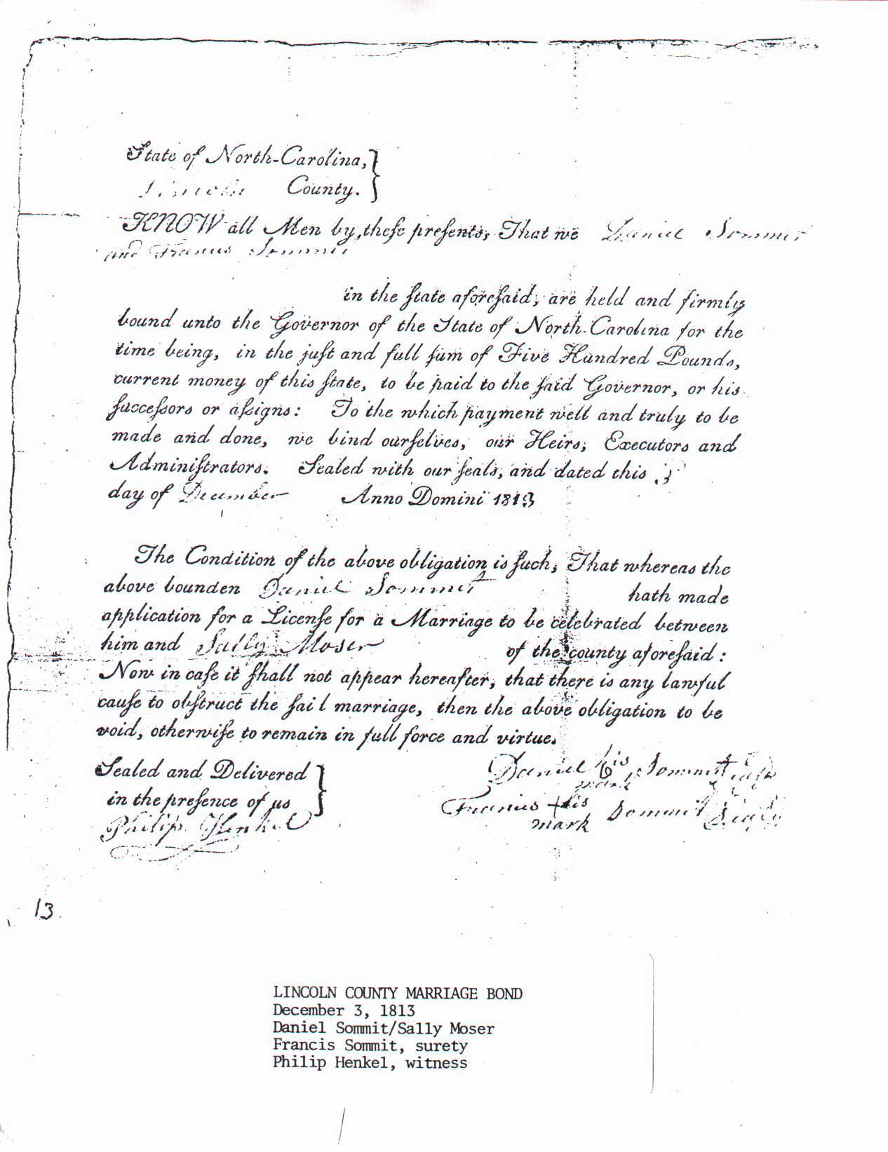

Daniel Summit, Sr. and Sarah Moser Marriage Bond

Daniel SUMMIT lived in Lincoln, North Carolina, in 1814[9]. Daniel and his brother Francis Jr. served as privates in the War of 1812 in a regiment from Lincoln County in Captain Daniel Hoke's Company recruited in 1814. The outbreak in the South was with Shawnee Chief Tecumseh and the Creek Indians, who raided Fort Mimms, Georgia, and scalped over 500 inhabitants. Tennessee was the quickest to react, and General Andrew Jackson mustered a large army and marched toward the uprising. The Georgia, Louisiana, and Mississippi Militias joined Jackson's forces, and the combined force defeated the Indians at the Battle of Horse Shoe Bend in Alabama.

The Western North Carolina troops mustered at Salisbury on February 1, 1814, marched under General Joseph Graham to Fort Hawkins, Georgia, and arrived by the end of March. By the time they reached Alabama, Jackson's troops had claimed victory. The North Carolinians could only help up the scattered warriors, and they assisted in the construction of four forts along the Alabama River. They returned on June 25 and arrived in North Carolina by the middle of August. The force suffered few casualties and injuries during the endeavor. Generally, this marked the conclusion of local participation in the War but still served to disrupt many households during the prime agricultural season[10].  
  
It's unknown whether Daniel participated in all or part of this expedition into Georgia and Alabama from February 1, 1814, through the middle of August 1814. His eldest son, Jacob Eusebius was born in Lincoln County, North Carolina on February 10, 1815, indicating Daniel was presumably with his wife sometime around May 1814[11]. That month the Treaty of Ghent was ratified by the US Senate and signed by President [James Madison](https://www.onthisday.com/people/james-madison) ending the War of 1812, over a month after it was signed in Europe[12].

Daniel’s son Jonathan, my great-great-grandfather, was born in Greene County, Tennessee on January 26, 1817. Daniel was 21[13]. That same month Argentine general [José de San Martín](https://www.onthisday.com/people/jose-de-san-martin) led a revolutionary army over the Andes to attack Spanish royalists in Chile[14].

His daughter Lydia "Lity" was born in Greene County, Tennessee on February 18, 1818. Daniel was 22[15]. That month Chile gained its independence from Spain[16].

Daniel’s father Francis died nine days later in Conover, North Carolina on February 27, 1818. Francis was 77 and Daniel was 22[17].

His daughter Lucinda was born in Monroe County, Tennessee on December 14, 1818[18]. That month Illinois became the twenty-first state of the nation. Also, the first known Christmas carol, "Silent Night, Holy Night" (Stille Nacht, Heilige Nacht'), was sung in Austria[19].

Daniel’s brother Jacob died in Paradise, Pennsylvania on December 30, 1820. Daniel was 25[20]. That month the state of Missouri imposed a $1 bachelor tax on all unmarried men between the ages of 21 and 50[21].

Daniel’s daughter Margaret was born in Greene County, Tennessee on September 17, 1821. Daniel was 26.

His son Joseph Lafayette was born in Madisonville, Monroe County, Tennessee on May 19, 1824. Daniel was 29[22]. His daughter Isabella was also born in 1824[23]. That month [Ludwig van Beethoven](https://www.onthisday.com/people/ludwig-van-beethoven)'s 9th (Choral) Symphony, often regarded as his greatest work, premiered at the Theater am Kärntnertor in Vienna, Austria. Also, Pope Leo XII proclaimed a Universal Jubilee trying to strengthen a closer bond between the Pope and the Christian people[24].

Daniel’s son John Francis was born in Jefferson City, Jefferson County, Tennessee on February 16, 1826. Daniel was 30[25]. The signing of the Treaty of Yandaboo marked the end of the First Burmese War. Biela's Comet was rediscovered by the Austrian astronomer Wilhelm von Biela. It was originally discovered in 1772[26].

Daniel’s daughter Susannah was born in Jefferson City, Jefferson County, Tennessee on November 10, 1827. Daniel was 32[27]. This was also the thirty-second anniversary of the birth of the US Marine Corps. Daniel’s mother Dolly died in 1827 in Lincoln, Catawba County, North Carolina. She was 72[28].

Daniel’s daughter Elizabeth was born in Jefferson County, Tennessee in 1829[29]. Daniel was 34. His son Daniel, Jr. was born in 1829 in Tennessee[30].

In 1830Daniel SUMMIT and his family lived in Jefferson County, Tennessee. Daniel was 35[31]. 1830 saw US President [Andrew Jackson](https://www.onthisday.com/people/andrew-jackson) sign the Indian Removal Act. This was a key law leading to the forced removal of the Cherokee, Chickasaw, Choctaw, Creek, and Seminole tribes out of Georgia and surrounding states. This set the stage for the Cherokee “[Trail of Tears](https://www.onthisday.com/photos/trail-of-tears).” A great fire in New Orleans was thought to have been set by slaves. The Book of Mormon was published in Palmyra, New York. The First Negro Convention of Free Men agreed to boycott slave-produced goods[32].

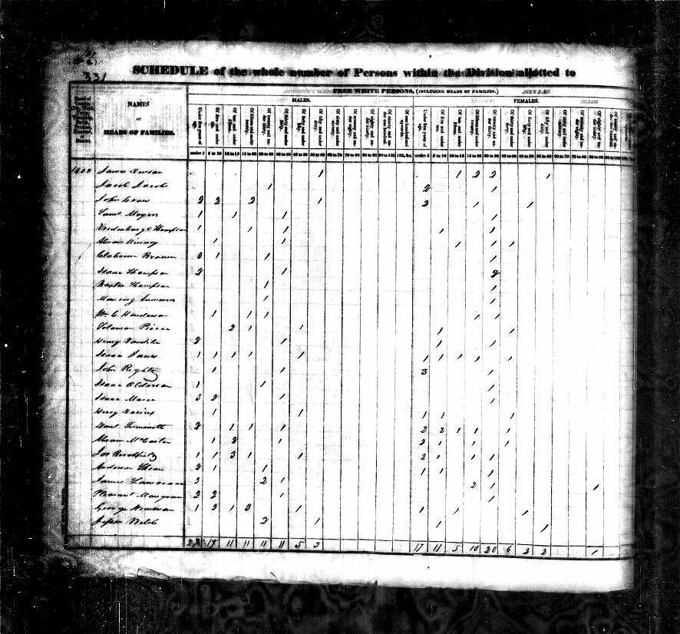

1830 United States Federal Census

Daniel’s brother John died in Madison, Missouri in 1831 when Daniel was 36[33]. [William Lloyd Garrison](https://www.onthisday.com/people/william-lloyd-garrison) published the first issue of the abolitionist newspaper "The Liberator" in Boston. The publication continued until the 13th Amendment abolished slavery in 1865.  Polish revolutionaries defeated Russian forces in the battle of Growchow. [Edgar Allan Poe](https://www.onthisday.com/people/edgar-allan-poe) was court-martialed and dismissed from West Point military academy for gross neglect of duty and disobedience of orders. Former slave [Nat Turner](https://www.onthisday.com/people/nat-turner) led an uprising against slavery in August.  Louisiana and Arkansas were the first states to observe Christmas as a holiday[34].

Daniel’s sister Catherine died in 1832 when Daniel was 37[35]. In Trinidad, negroes revolted. The New England Anti-Slavery Society was organized in Boston. The Polish constitution was abolished and replaced by Tsar [Nicholas I](https://www.onthisday.com/people/nicholas-i). The Mormon leader [Joseph Smith](https://www.onthisday.com/people/joseph-smith-jr) was beaten, tarred, and feathered in Hiram, Ohio. [Andrew Jackson](https://www.onthisday.com/people/andrew-jackson) was re-elected as US President after defeating [Henry Clay](https://www.onthisday.com/people/henry-clay). [John C. Calhoun](https://www.onthisday.com/people/john-c-calhoun) became the first Vice-President to resign over differences with President Jackson[36].

Daniel’s son Peter was born in Jefferson City, Jefferson County, Tennessee on February 11, 1833. Daniel was 37[37]. In 1833 Russia and Turkey signed a defense treaty. Britain's Slavery Abolition Act gained royal assent. Britain’s First Factory Act became law "to regulate the Labour of Children and young Persons in the Mills and Factories of the United Kingdom[38]."

Daniel SUMMIT died in Monroe County, Tennessee on September 30, 1838. Daniel was 43[39]. That year about 50 Wirrayaraay Indigenous people were killed by New South Wales Mounted Police in what became known as the Myall Creek Massacre. Seven men later became the first ever to be hanged for killing Australian Aborigines. Fire destroyed half of Charleston, South Carolina. Twenty-six children drowned while trying to escape flooding in the Silkstone Colliery in England. Known as the Huskar Pit Disaster, this tragedy led to the 1842 Mines Act, which banned women and children from working underground[40].

[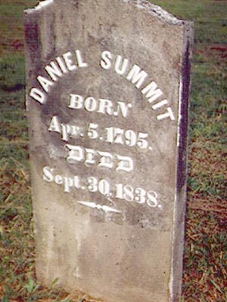](https://www.ancestry.com/mediaui-viewer/tree/15293711/person/367252042/media/c3cb729d-3088-48f8-8e19-8a39ea430df0)

Daniel Summit Headstone - 1705-1838

1. https://www.ancestry.com/discoveryui-content/view/9015057:60525?ssrc=pt&tid=15293711&pid=367252042
2. February 1999, *DANIEL SUMMIT*: SON OF FRANCIS SUMMIT, by Paul C. Summitt. Also published in revised form in The Summitt Family Quarterly, Vol. 2, Issue 1 (Spring 1996)
3. AncestryAI Beta
4. https://www.onthisday.com/events/date/1795
5. [Geneanet Community Trees Index](https://search.ancestry.com/cgi-bin/sse.dll?indiv=1&dbid=62476&h=7294687388&tid=15293711&pid=367307541&hid=1015634342842&usePUB=true&_phsrc=DeF37&_phstart=default&usePUBJs=true&currentPageIsStart=&hintStatus=pending)
6. https://www.onthisday.com/events/date/1797
7. <http://search.ancestry.com/cgi-bin/sse.dll?db=worldmarr_ga&h=866818&ti=0&indiv=try&gss=pt>
8. https://www.onthisday.com/date/1813/december
9. North Carolina Census, 1790-1890
10. Ashe's "History of North Carolina", p. 235
11. U.S., Find A Grave Index, 1600s-Current
12. https://www.onthisday.com/date/1815/february
13. Web: Tennessee, Find A Grave Index, 1777-2012
14. https://www.onthisday.com/date/1817/january
15. [Tennessee, U.S., Death Records, 1908-1965](https://search.ancestry.com/cgi-bin/sse.dll?indiv=1&dbid=2376&h=30571225&tid=15293711&pid=245041487&hid=1015629745564&usePUB=true&_phsrc=DeF44&_phstart=default&usePUBJs=true&currentPageIsStart=&hintStatus=pending)
16. https://www.onthisday.com/date/1818/february
17. <http://search.ancestry.com/cgi-bin/sse.dll?db=websearch-4118&h=39600&ti=0&indiv=try&gss=pt>
18. <http://search.ancestry.com/cgi-bin/sse.dll?db=1850usfedcenancestry&h=6431679&ti=0&indiv=try&gss=pt>
19. https://www.onthisday.com/date/1818/december
20. Savannah, Georgia Vital Records, 1803-1966
21. https://www.onthisday.com/date/1820/december
22. https://www.ancestry.com/discoveryui-content/view/1105002:70636?ssrc=pt&tid=15293711&pid=18390715617
23. <https://gw.geneanet.org/marionwetterer?n=summitt&oc=&p=isabella>
24. https://www.onthisday.com/date/1824/may
25. https://www.ancestry.com/discoveryui-content/view/95643422:60525?ssrc=pt&tid=15293711&pid=18184392469
26. https://www.onthisday.com/date/1826/february
27. U.S., Find A Grave Index, 1600s-Current
28. <https://gw.geneanet.org/addettergen?n=abernathy+or+doe&oc=&p=dorothea+dolly>
29. [Tennessee, U.S., Death Records, 1908-1965](https://search.ancestry.com/cgi-bin/sse.dll?indiv=1&dbid=2376&h=30658452&tid=15293711&pid=5072237323&hid=1015507326086&usePUB=true&_phsrc=DeF56&_phstart=default&usePUBJs=true&currentPageIsStart=&hintStatus=pending)
30. <https://gw.geneanet.org/sdowellhill?n=summitt&oc=&p=dan>
31. <http://search.ancestry.com/cgi-bin/sse.dll?db=1830usfedcenancestry&h=749737&ti=0&indiv=try&gss=pt>
32. https://www.onthisday.com/events/date/1830
33. <https://gw.geneanet.org/addettergen?n=summit&oc=1&p=john>
34. https://www.onthisday.com/events/date/1831
35. <https://gw.geneanet.org/addettergen?n=summit&oc=&p=catharine>
36. https://www.onthisday.com/events/date/1832
37. <http://search.ancestry.com/cgi-bin/sse.dll?db=tndeathrecords&h=29606&ti=0&indiv=try&gss=pt>
38. https://www.onthisday.com/events/date/1833
39. https://www.ancestry.com/discoveryui-content/view/1097190:70636?ssrc=pt&tid=15293711&pid=367252042
40. https://www.onthisday.com/events/date/1838